Question 1 –

Code :

#include <stdio.h>

#include <stdlib.h>

int main()

{

//q1

int x,y;

printf("enter the two numbers : ");

scanf("%d %d",&x,&y);

printf("the result = %d \n",((x+y)\*3)-10);

return 0;

}

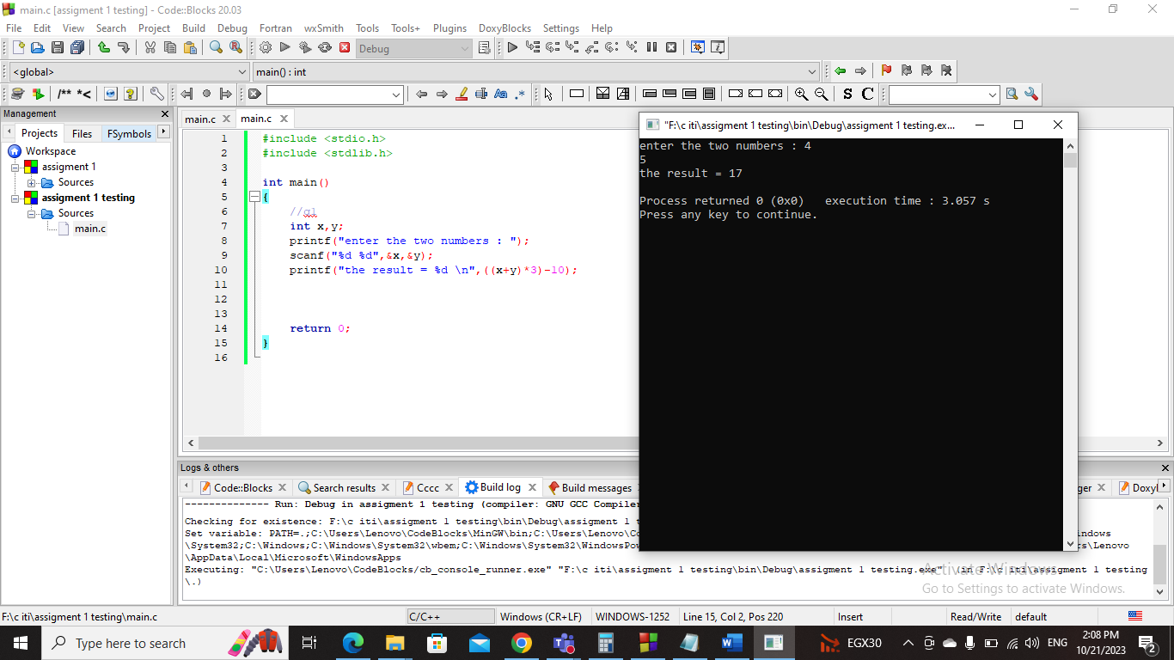Screenshot :

Question 2 –

Code :

#include <stdio.h>

#include <stdlib.h>

int main()

{

//q2

char name[20];

int grade;

printf("enter your name : ");

scanf("%s",&name);

printf("enter your grade : ");

scanf("%d",&grade);

printf("your name is : %s \n",name);

printf("your grade is : %d \n",grade);

return 0;

}

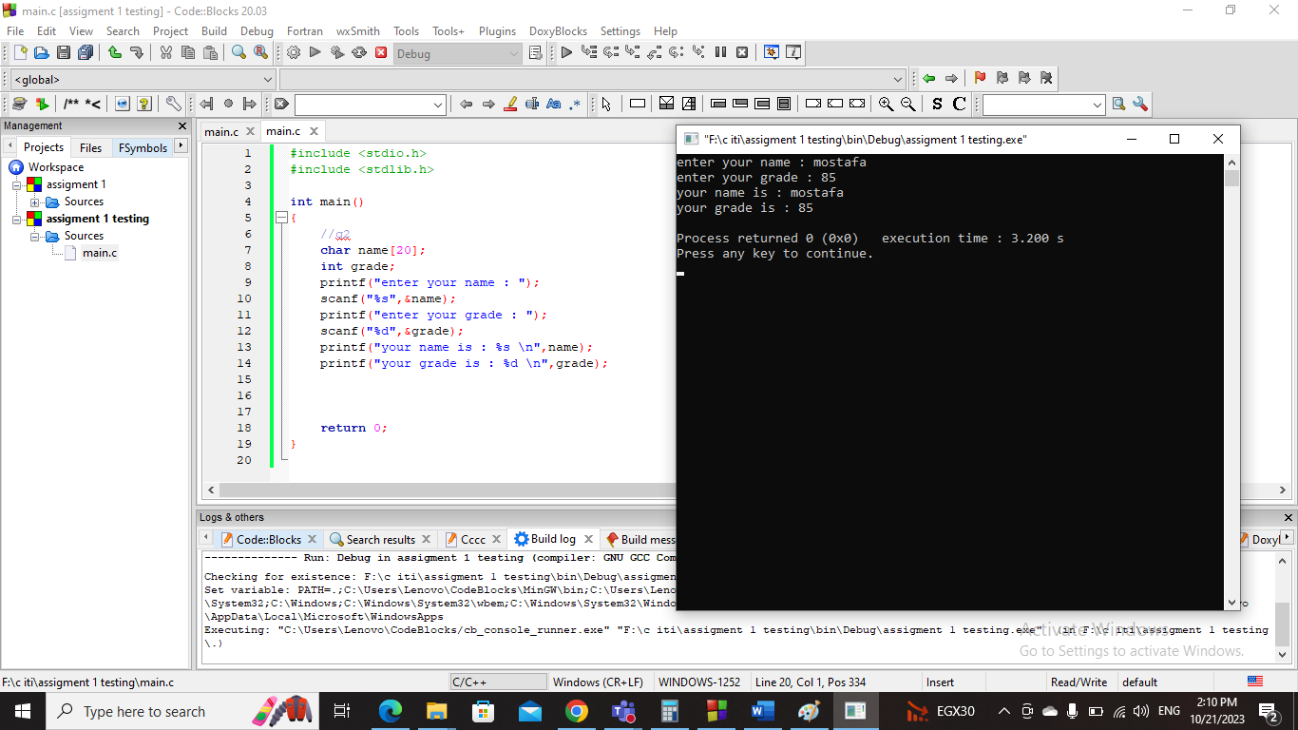Screenshot :

Question 3 –

Code :

#include <stdio.h>

#include <stdlib.h>

int main()

{

//q3

int degree;

printf("enter the degree in celsius : ");

scanf("%d",&degree);

printf("the temperature in fahrenheit : %f \n",(float)degree\*1.8+32);

return 0;

}

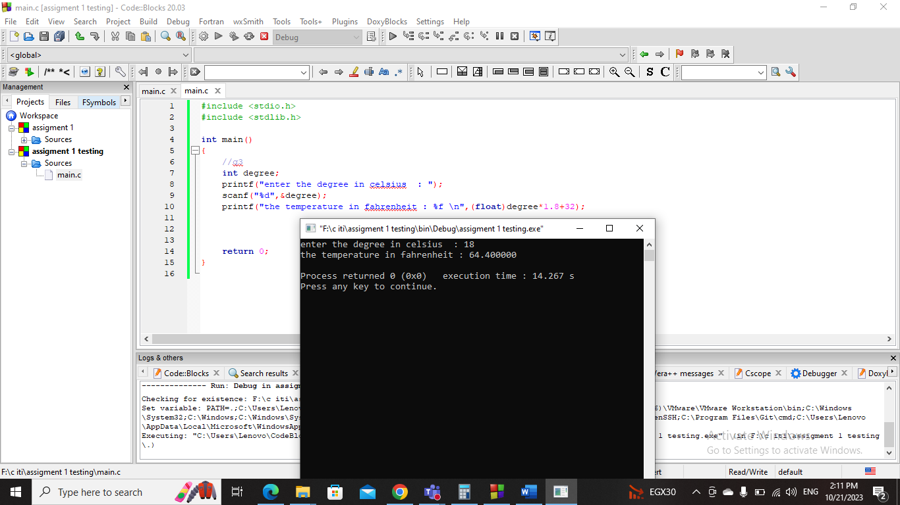Screenshot :

Question 4 –

Code :

#include <stdio.h>

#include <stdlib.h>

int main()

{

//q4

float radius;

printf("enter the radius : ");

scanf("%f",&radius);

float area = 3.14 \* radius \* radius;

printf("circle area = %f \n",area);

return 0;

}

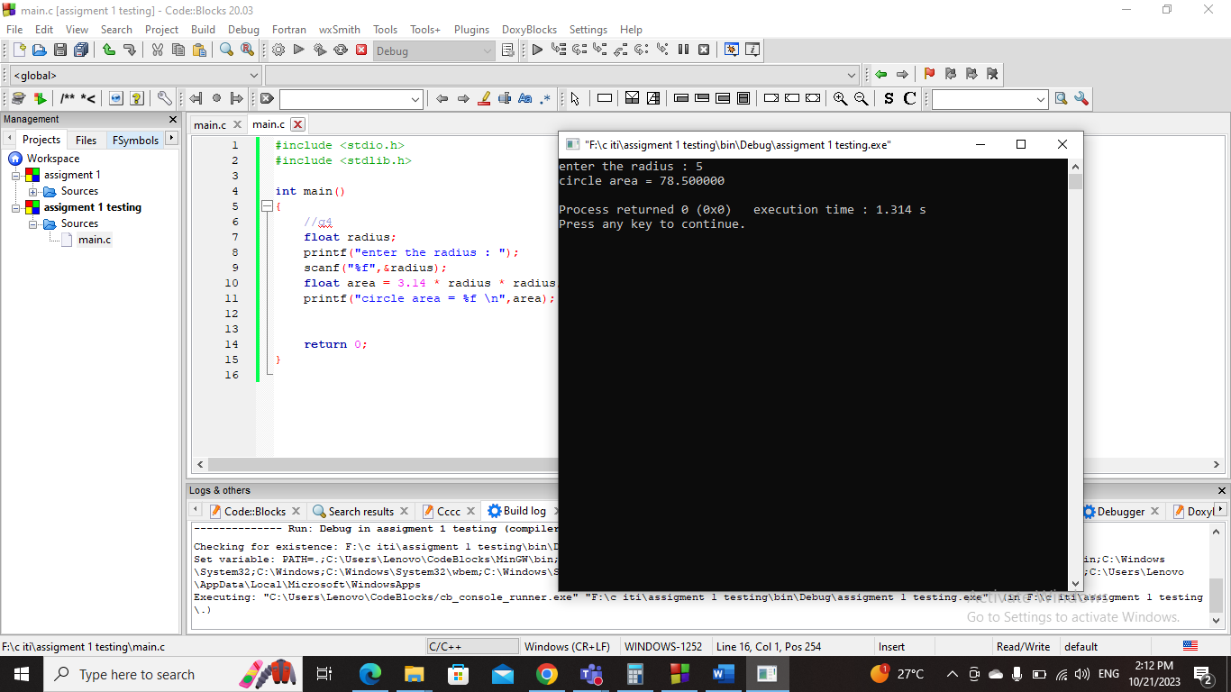Screenshot :

Question 5 –

Code :

#include <stdio.h>

#include <stdlib.h>

int main()

{

//q5

char x;

printf("enter the character : ");

scanf("%c",&x);

printf("ASCII number of %c is %d \n",x,x);

return 0;

}

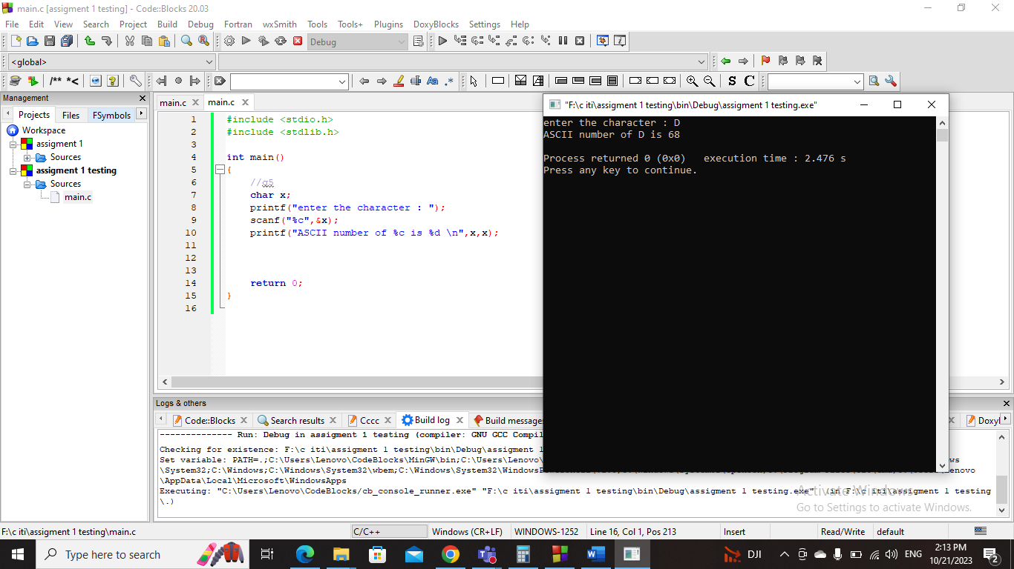Screenshot :

Question 6 –

Code :

#include <stdio.h>

#include <stdlib.h>

int main()

{

//q6

int x,y;

printf("enter the two numbers : ");

scanf("%d %d",&x,&y);

if(x == y){

printf("the two numbers are equal each other \n");

}else{

printf("the two numbers are not equal each other \n");

if(x > y){

printf("number %d is higher than %d \n",x,y);

}else{

printf("number %d is higher than %d \n",y,x);

}

}

return 0;

}

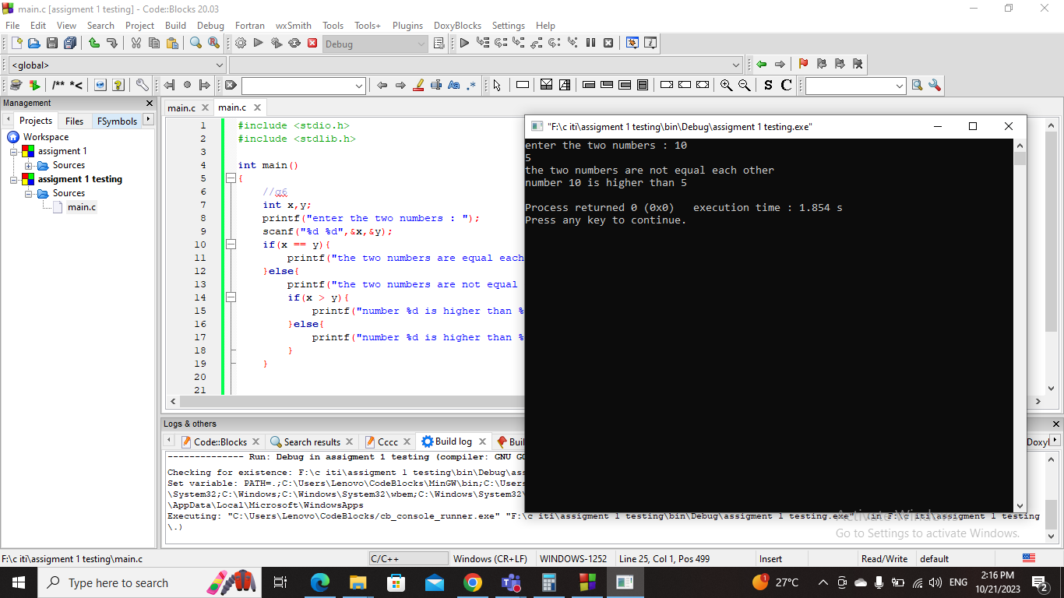Screenshot :

Question 7 –

Code :

#include <stdio.h>

#include <stdlib.h>

int main()

{

//q7

int arr[3];

printf("enter the three numbers : ");

for(int i=0 ; i<3 ; i++){

scanf("%d",&arr[i]);

}

int min = arr[0];

for(int i=1 ; i<3 ; i++){

if(min > arr[i]){

min = arr[i];

}

}

printf("the lowest number = %d \n",min);

return 0;

}

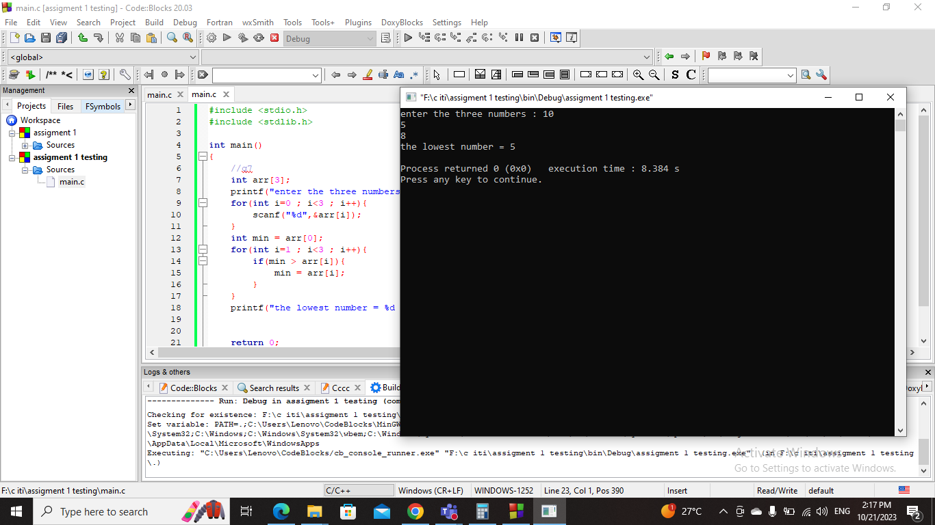Screenshot :

Question 8 –

Code :

#include <stdio.h>

#include <stdlib.h>

int main()

{

//q8

int number;

printf("enter the number : ");

scanf("%d",&number);

int flag=0;

for(int i=1 ; i\*i <=number ; i++){

if ((number % i == 0) && (number / i == i)) {

flag=1;

}

}

if(number ==0 || flag == 1){

printf("perfect square \n");

}else{

printf("not perfect square \n");

}

return 0;

}

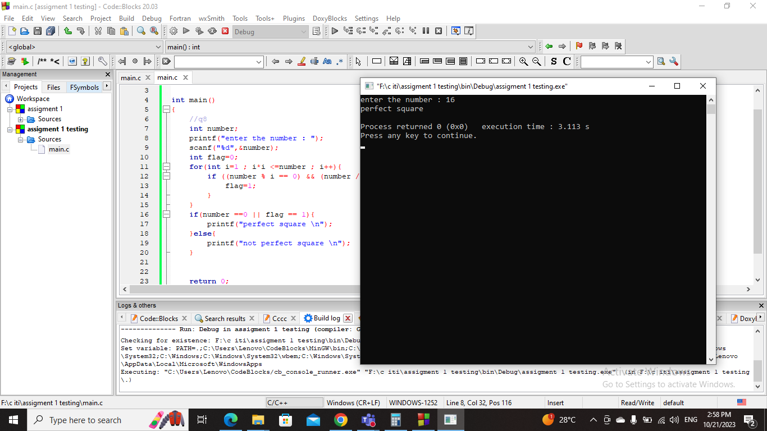Screenshot :

Question 9 –

Code :

#include <stdio.h>

#include <stdlib.h>

int main()

{

//q9

int grade;

printf("enter the grade : ");

scanf("%d",&grade);

if(grade < 0 || grade >100){

printf("wrong grade .. please enter your grade correct .");

}else if(grade < 50 ){

printf("Fail");

}else if(grade >=50 && grade<65 ){

printf("Pass");

}else if(grade >=65 && grade<75 ){

printf("Good");

}else if(grade >=75 && grade<85 ){

printf("V.Good");

}else if(grade >=85 ){

printf("Excellent");

}

return 0;

}

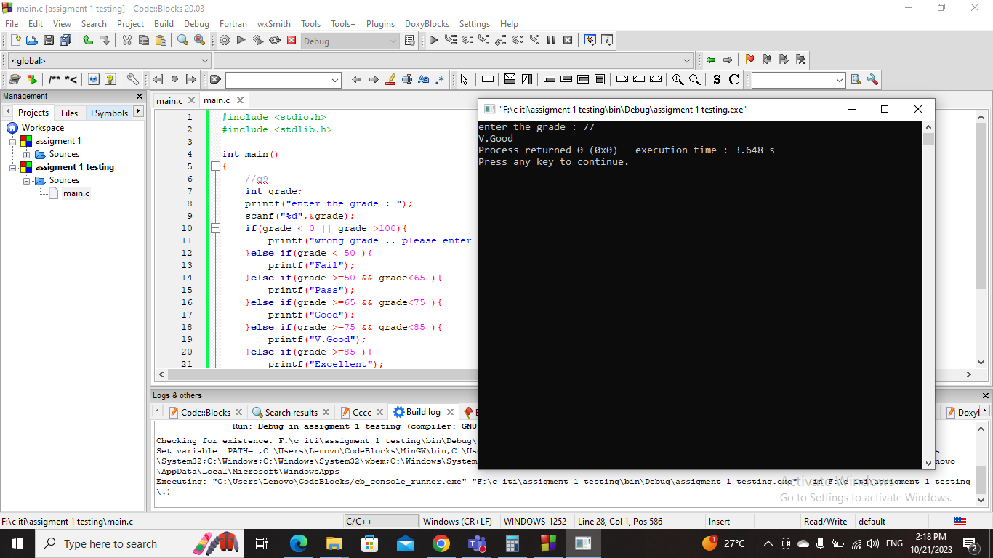Screenshot :

Question 10 –

Code :

#include <stdio.h>

#include <stdlib.h>

int main()

{

//q10

int x,y;

printf("enter the two numbers : ");

scanf("%d %d",&x,&y);

char z;

printf("enter the sign operation : ");

scanf(" %c",&z);

switch(z){

case '+':

printf("the sum : %d \n",x+y);

break;

case '-':

printf("the sub : %d \n",x-y);

break;

case '\*':

printf("the multiplication : %d \n",x\*y);

break;

case '/':

printf("the division : %d \n",x/y);

break;

default:

printf("wrong sign operation ...");

break;

}

return 0;

}

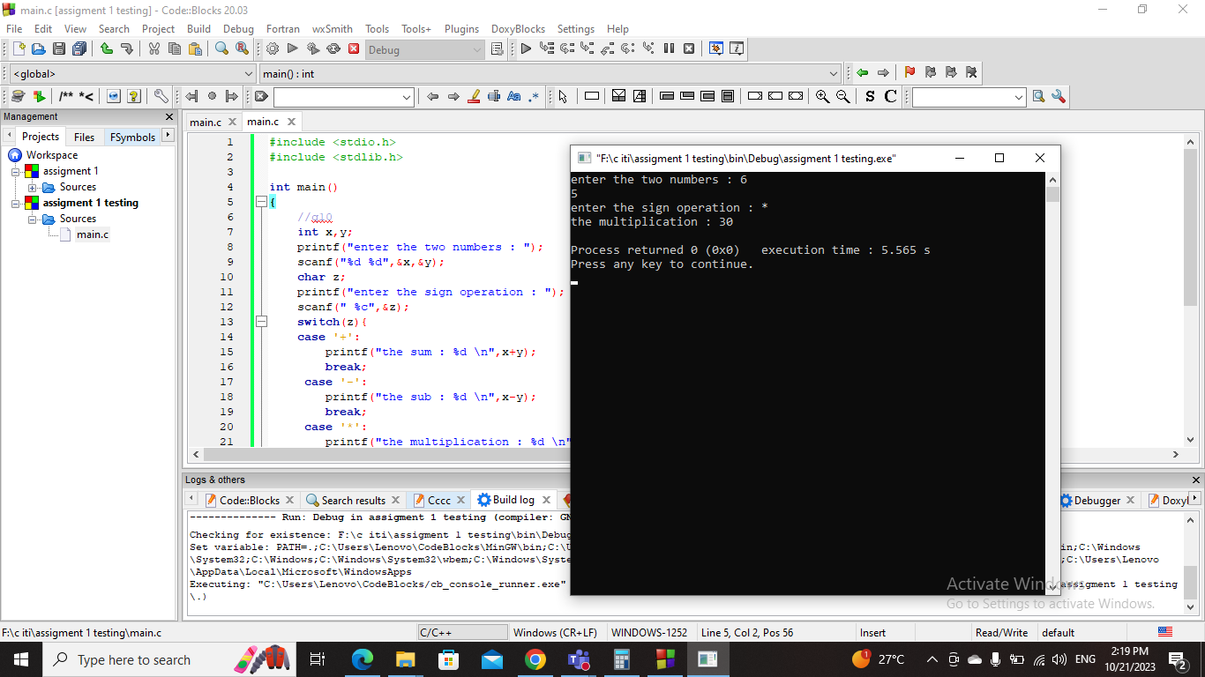Screenshot :

Question 11 –

Code :

#include <stdio.h>

#include <stdlib.h>

int main()

{

//q11

int sum=0;

for(int i=1 ; i<=100 ; i++){

sum+= i;

}

printf("the sum of the first 100 integers = %d",sum);

return 0;

}

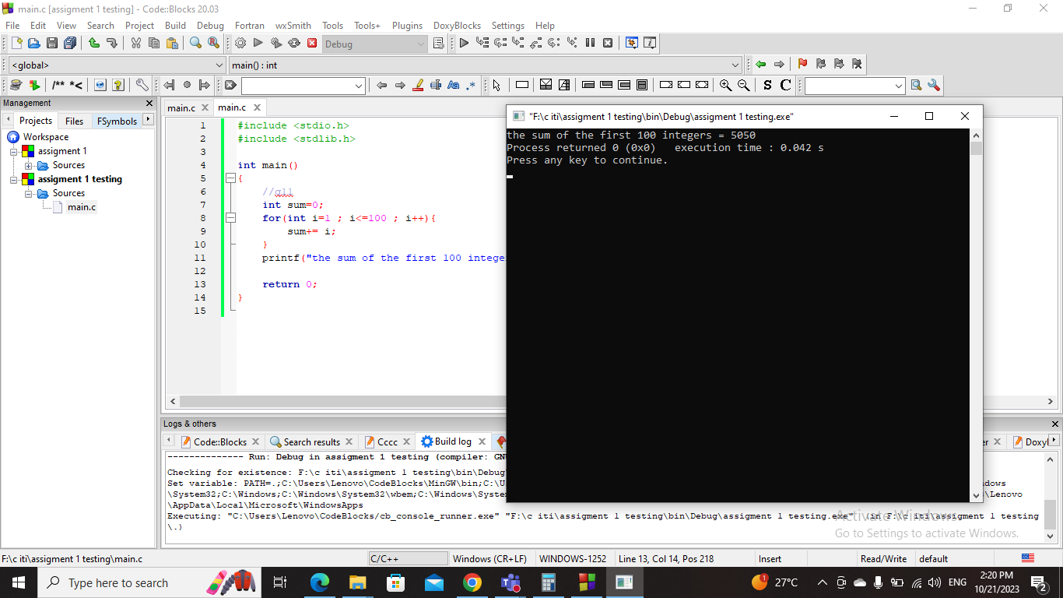Screenshot :

Question 12 –

Code :

#include <stdio.h>

#include <stdlib.h>

int main()

{

//q12

int x;

printf("enter positive integer : ");

scanf("%d",&x);

if(x <= 0){

printf("this is negative number or zero not positive number !");

}else{

int factorial = 1;

for(int i=x ; i>=1 ; i--){

factorial\*= i;

}

printf("the factorial is = %d \n",factorial);

}

return 0;

}

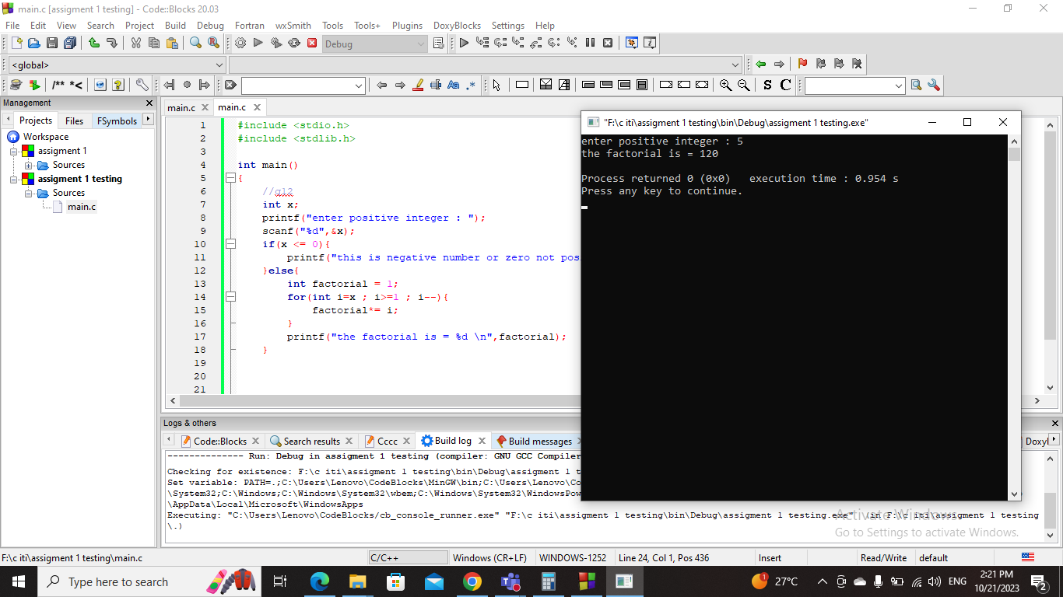Screenshot :

Question 13 –

Code :

#include <stdio.h>

#include <stdlib.h>

int main()

{

//q13

int x;

printf("enter the number : ");

scanf("%d",&x);

int flag;

if(x < 0 ){

printf("this is negative number ... enter positive one");

}else if(x == 0 || x == 1 || x == -1){

printf("not prime number \n");

}

else{

for(int i=2 ; i<= x/2 ; i++){

if(x % i == 0){

flag = 1;

break;

}

}

if(flag == 0){

printf("prime number \n");

}else{

printf("not prime number \n");

}

}

return 0;

}

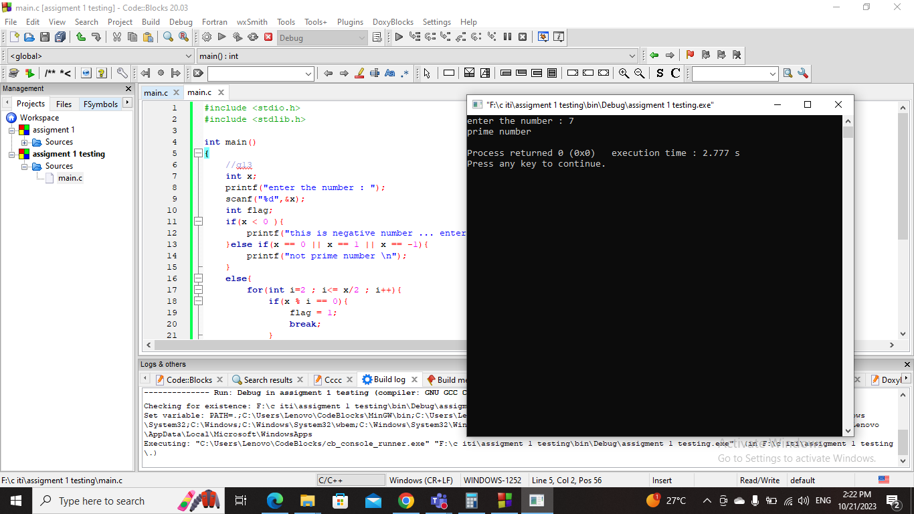Screenshot :

Question 14 –

Code :

#include <stdio.h>

#include <stdlib.h>

int main()

{

//q14

for(int i=65 ; i<91 ; i++){

printf("%c \n",i);

}

return 0;

}

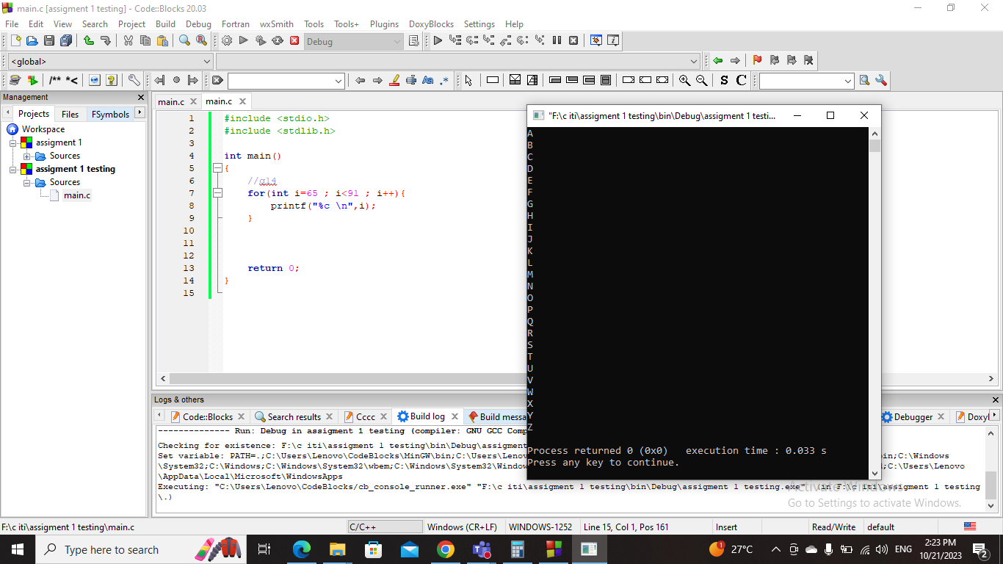Screenshot :

Question 15 –

Code :

#include <stdio.h>

#include <stdlib.h>

int main()

{

//q15

int number , power;

printf("enter the number : ");

scanf("%d",&number);

printf("enter the power : ");

scanf("%d",&power);

int result=number;

for(int i=2 ; i<=power ; i++){

result\*= number;

}

printf("the power = %d \n",result);

return 0;

}

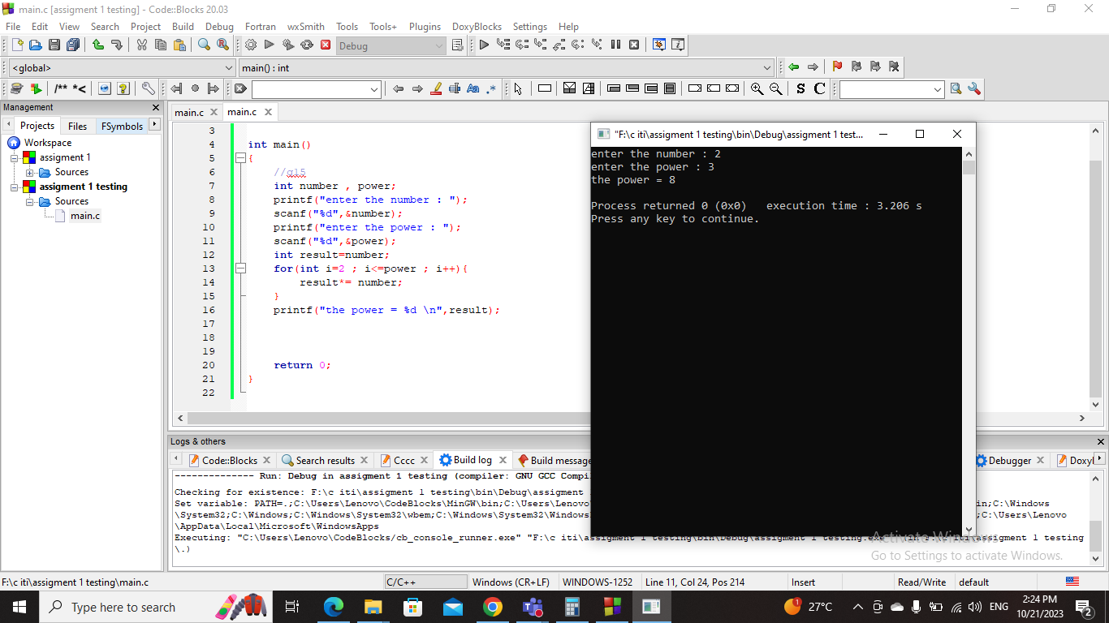Screenshot :

Question 16 –

Code :

#include <stdio.h>

#include <stdlib.h>

int main()

{

//q16

int number;

printf("enter the number : ");

scanf("%d",&number);

int digit=0;

while(number != 0){

digit+= number%10;

number/= 10;

if(number !=0){

digit\*= 10;

}

}

printf("the reversed number = %d \n",digit);

return 0;

}

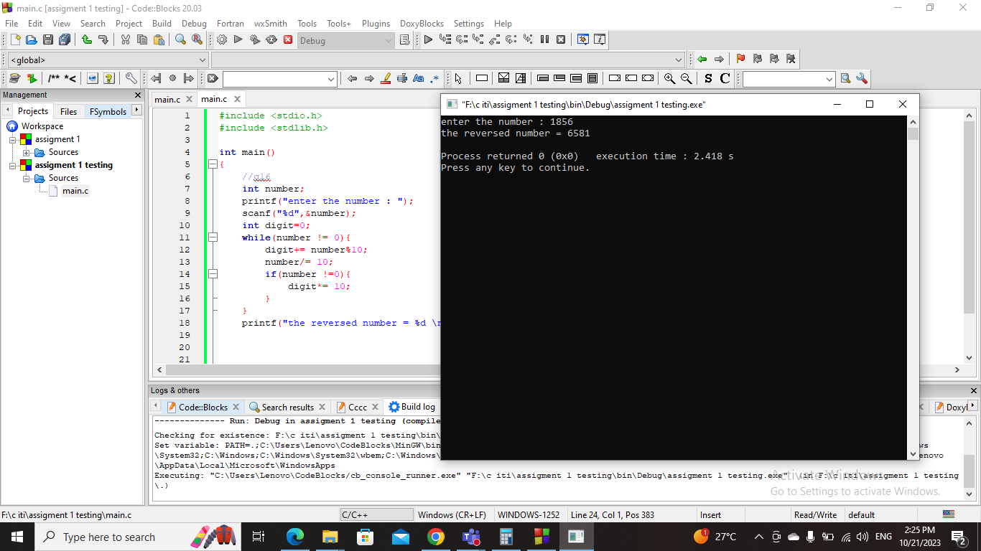Screenshot :

Question 17 –

Code :

#include <stdio.h>

#include <stdlib.h>

int main()

{

//q17

int number;

printf("enter the number : ");

scanf("%d",&number);

int digit=0;

while(number!= 0){

digit++;

number/= 10;

}

printf("the number of digits = %d \n",digit);

return 0;

}

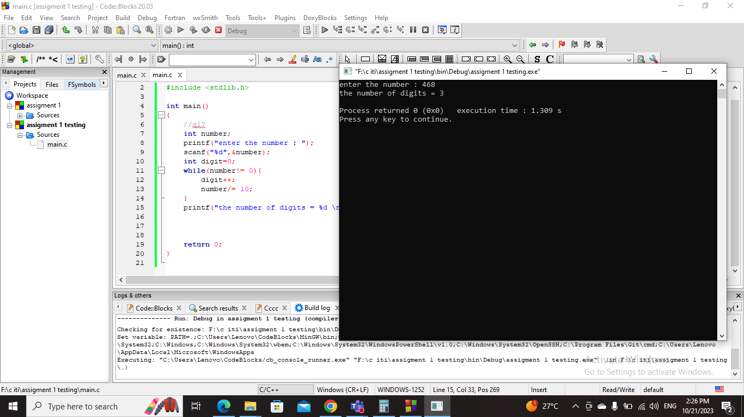Screenshot :

Question 18 –

Code :

#include <stdio.h>

#include <stdlib.h>

int main()

{

//q18

int number;

printf("enter the number");

scanf("%d",&number);

for(int i=1 ; i<=number ; i++){

for(int j=1 ; j<=i ; j++){

printf("\*");

}

printf("\n");

}

return 0;

}

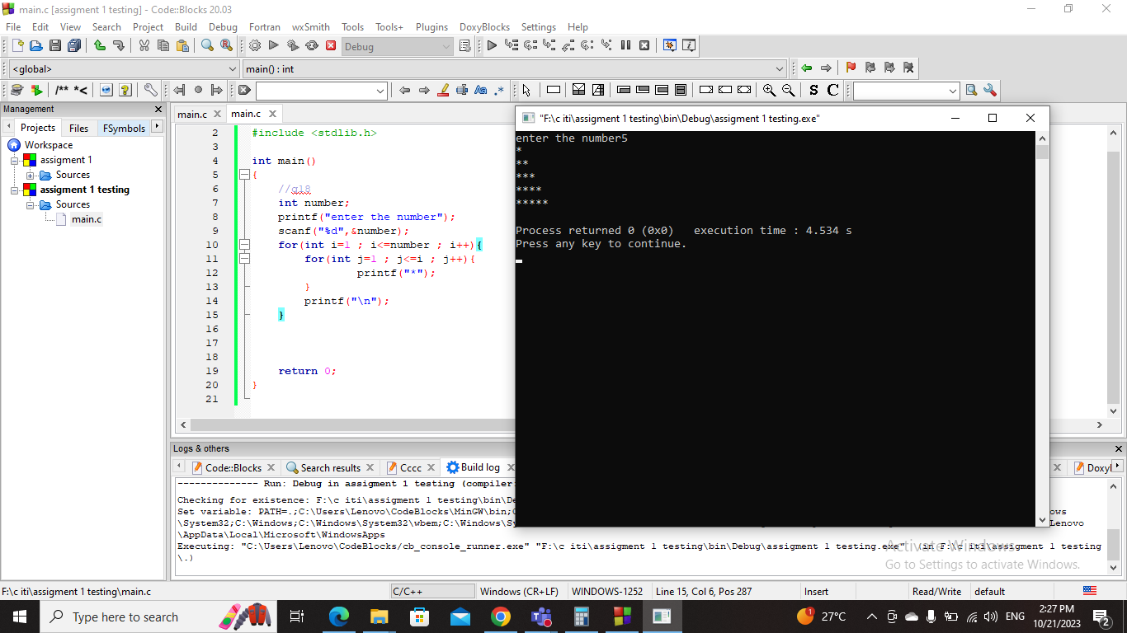Screenshot :

Question 19 –

Code :

#include <stdio.h>

#include <stdlib.h>

int main()

{

//q19

int number;

printf("enter the number");

scanf("%d",&number);

for(int i=1 ; i<=number ; i++){

for(int j=0 ; j<=number-i ; j++){

printf("\*");

}

printf("\n");

}

return 0;

}

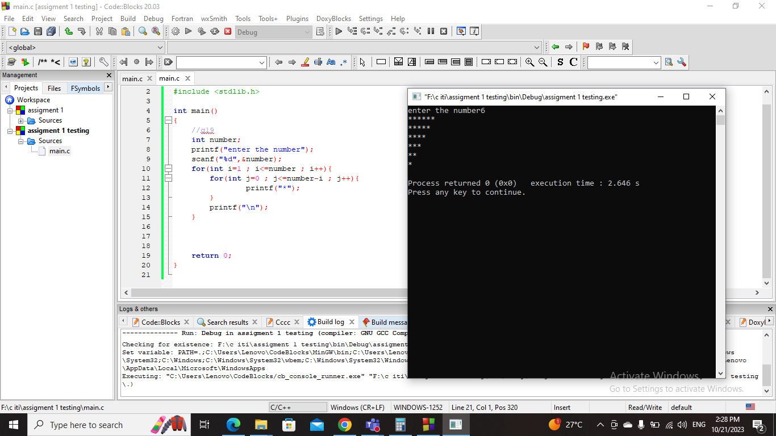Screenshot :

Question 20 –

Code :

#include <stdio.h>

#include <stdlib.h>

int main()

{

//q20

int number;

printf("enter the number");

scanf("%d",&number);

for(int i=1 ; i<=number ; i++){

for(int k=1 ; k<=number-i ; k++){

printf(" ");

}

for(int j=1 ; j<=(2\*i)-1 ; j++){

printf("\*");

}

printf("\n");

}

return 0;

}

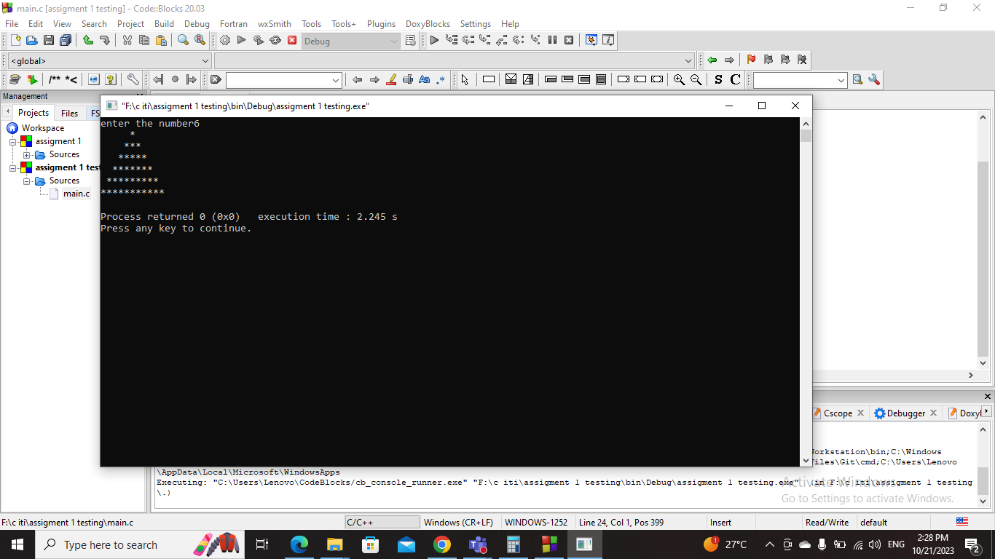Screenshot :

Question 21 –

Code :

#include <stdio.h>

#include <stdlib.h>

int main()

{

//q21

int number;

printf("enter the number");

scanf("%d",&number);

int z= number\*2;

int z2 = 0;

if(number <= 1){

printf("enter number bigger than 1 \n");

}

else{

for(int i=1 ; i<=number ; i++){

for(int k=1 ; k<=i-1 ; k++){

printf(" ");

}

printf("\*");

z = z-2;

int zz=z;

while(zz!= 0){

printf(" ");

zz--;

}

printf("\*");

printf("\n");

}

for(int i=number ; i<=number ; i++){

for(int k=1 ; k<=i-1 ; k++){

printf(" ");

}

printf("\*\*");

printf("\n");

}

for(int i=2 ; i<=number ; i++){

for(int k=1 ; k<=number-i ; k++){

printf(" ");

}

printf("\*");

z2 = z2+2;

int zz= z2;

for(int a=1 ; a<=zz ; a++){

printf(" ");

}

printf("\*");

printf("\n");

}

}

return 0;

}

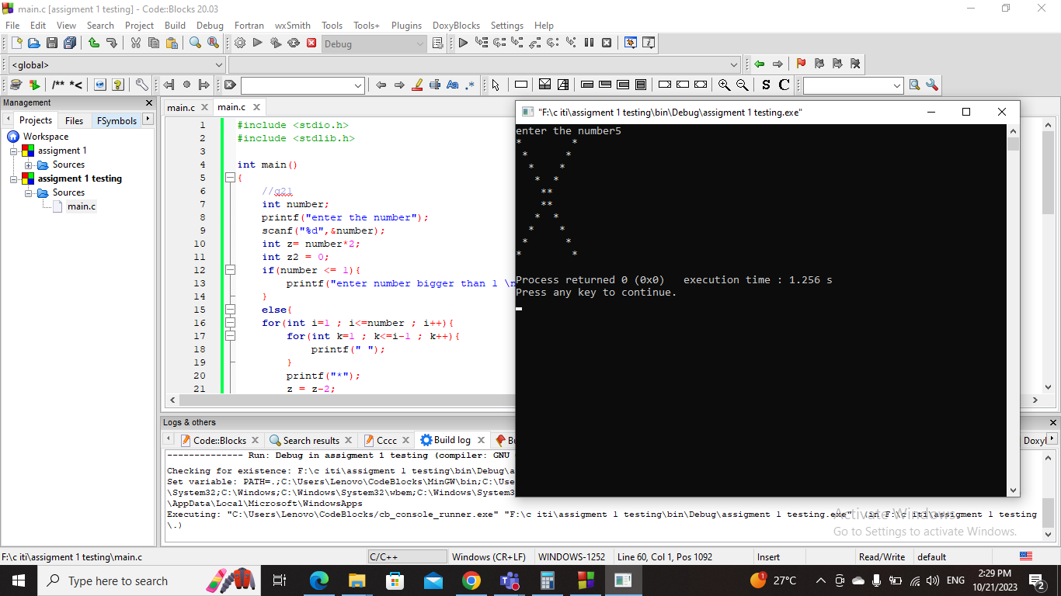Screenshot :